**Time Series**

# Set the date column as the index of your Data Frame and Plot the time series in your Data Frame with Specify the x-axis and y-axis label in your plot

**Multiple Time Series**

Printing the summary statistics of the Data Frame with time series dataset with additional customizations of colormap cubehelix and PuOr and Add summary table information to the plot

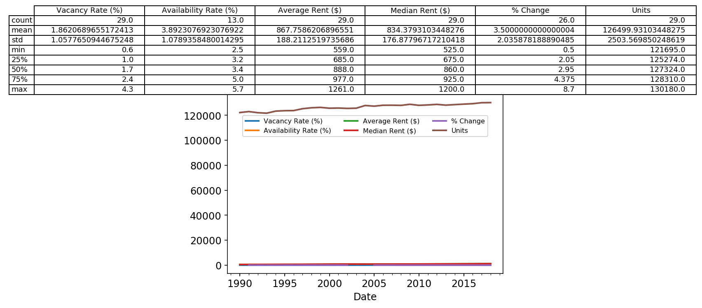

All graphs of 1 bed sharing the same x axis as they have different y values.

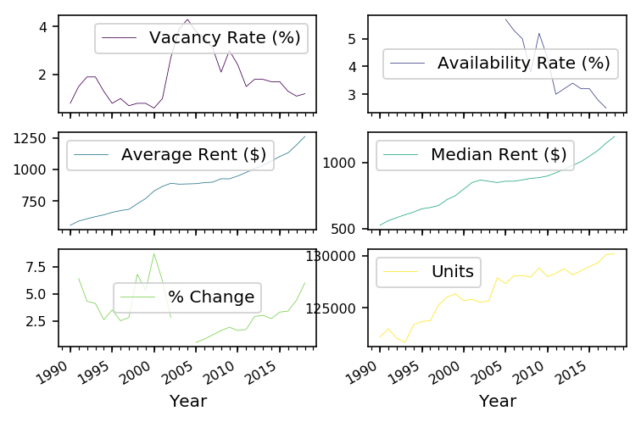

# Print the correlation matrix between the beef and pork columns using the spearman method

Vacancy Rate (%) Availability Rate (%)

Vacancy Rate (%) 1.000000 0.991216

Availability Rate (%) 0.991216 1.000000

Average Rent ($) Median Rent ($)

Average Rent ($) 1.000000 0.998303

Median Rent ($) 0.998303 1.000000

**Visualize correlation matrices**

The correlation matrix generated can be plotted using a heatmap with seaborn library.

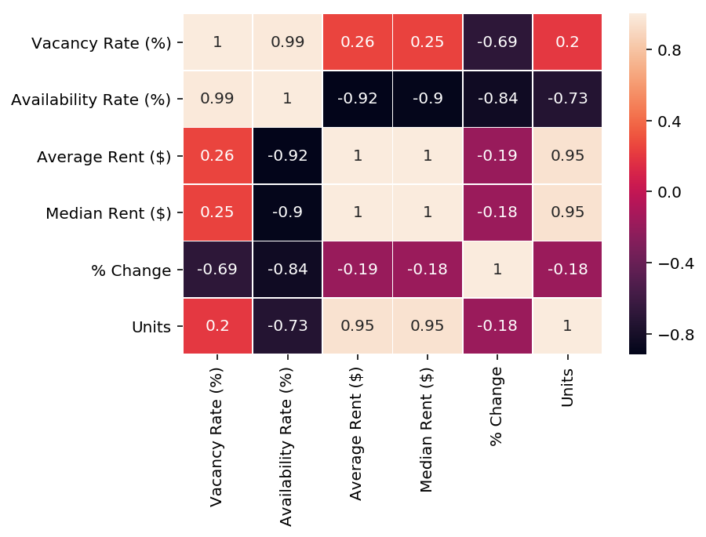

**Clustered heatmaps**

Heatmaps are extremely useful to visualize a correlation matrix, but clustermaps are better. A Clustermap allows to uncover structure in a correlation matrix by producing a hierarchically-clustered heatmap:

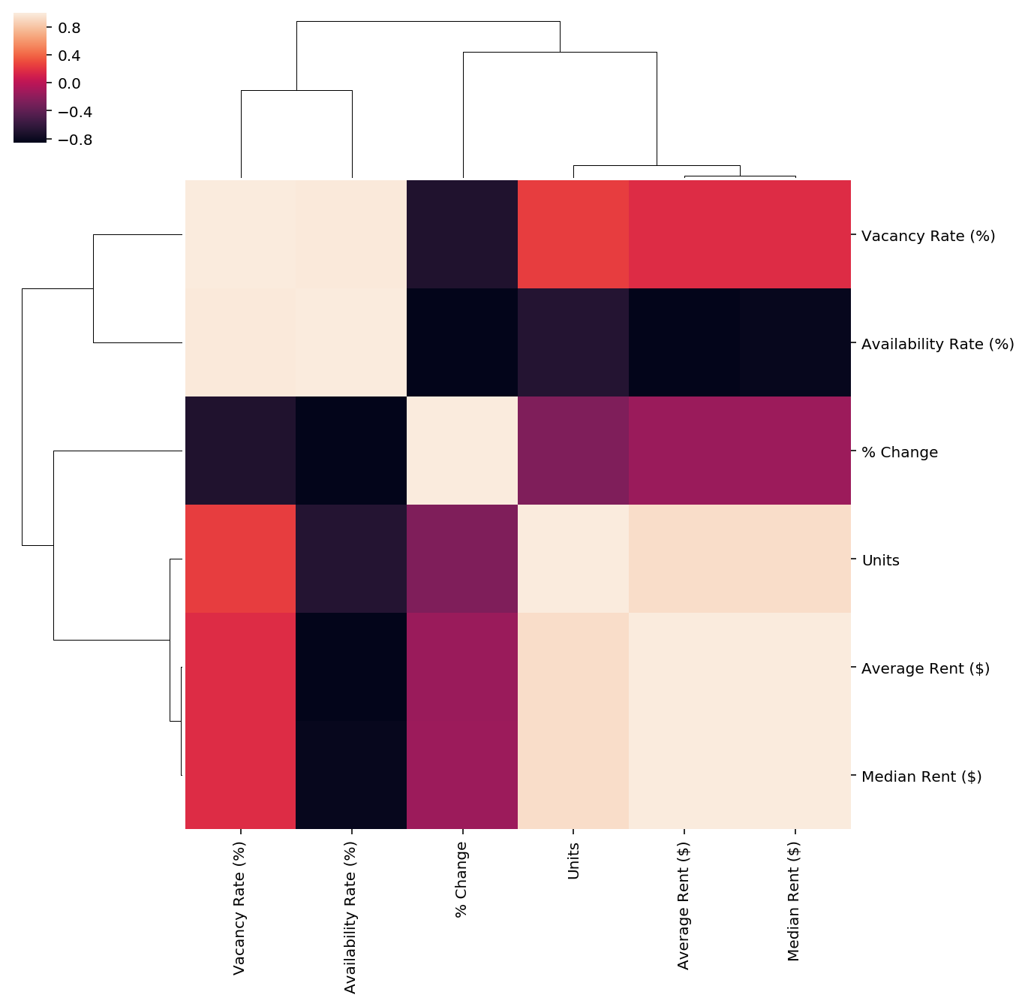

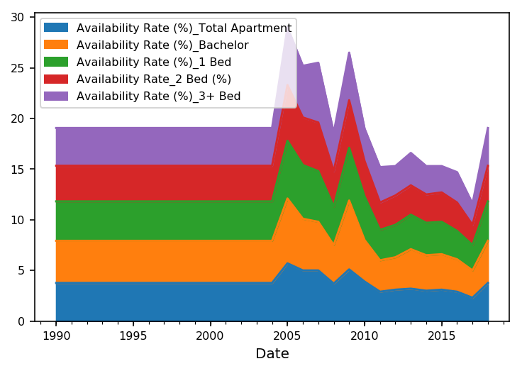

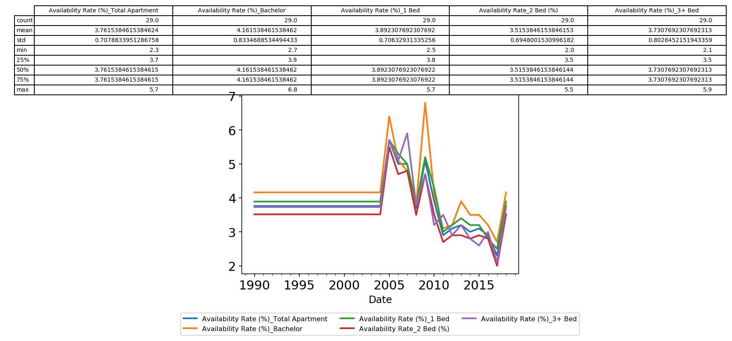

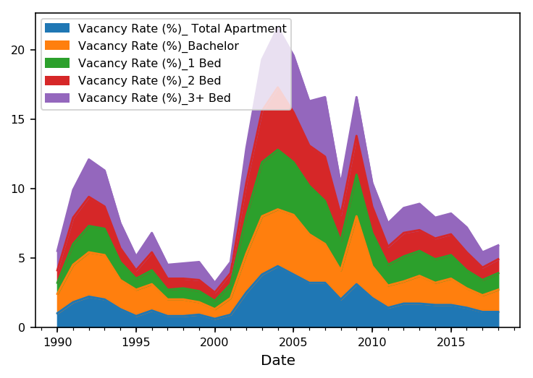

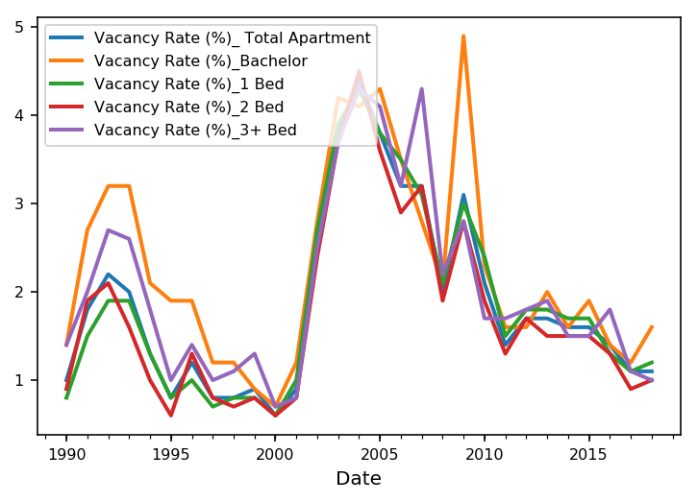

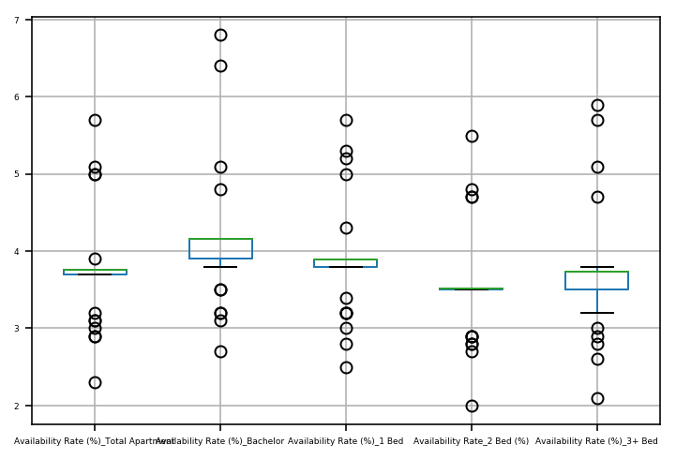

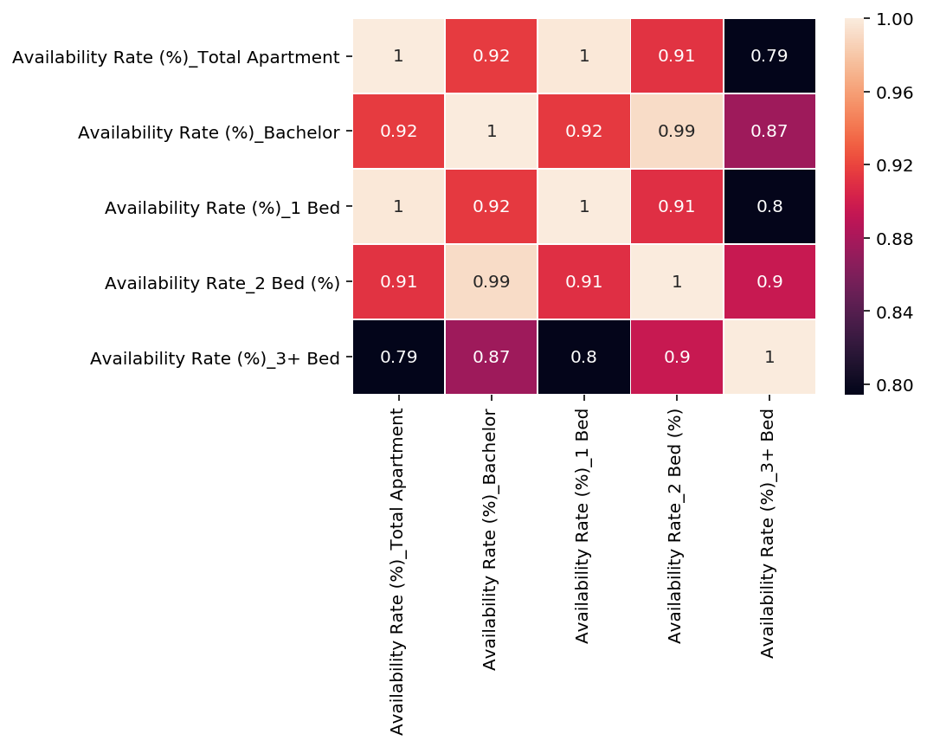

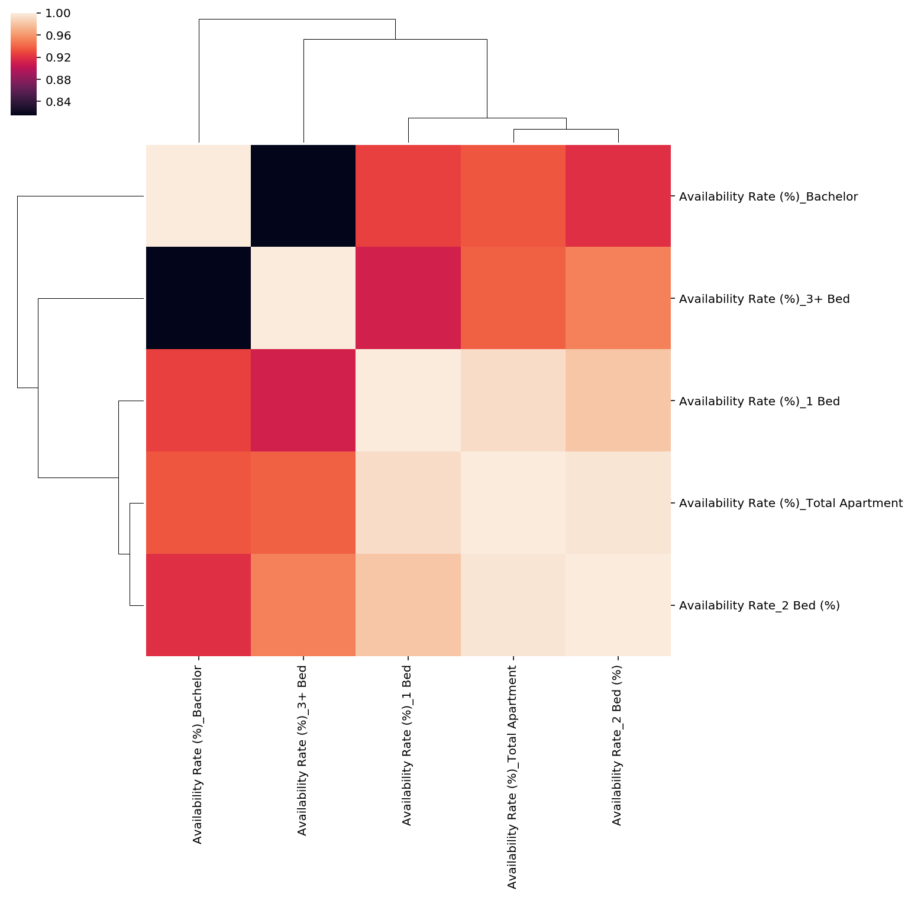

**https://www.kaggle.com/airbnb/seattle**

**Prediction:**

1. **Listing Price**
2. **Rating**
3. **Super Hosting Depend on what**
4. **Word cloud & frequency and Similar content based Recommendation**

**Boston:**

[**https://www.kaggle.com/kostyabahshetsyan/boston-airbnb-visualization**](https://www.kaggle.com/kostyabahshetsyan/boston-airbnb-visualization)

[**https://www.kaggle.com/aussie84/clustering-rooms-based-on-owner-s-descriptions**](https://www.kaggle.com/aussie84/clustering-rooms-based-on-owner-s-descriptions)

[**https://www.kaggle.com/zbi441/boston-airbnb-data-s1-seasonal-pattern-of-price**](https://www.kaggle.com/zbi441/boston-airbnb-data-s1-seasonal-pattern-of-price)

[**https://www.kaggle.com/alihussain1993/statistical-and-predictive-analysis**](https://www.kaggle.com/alihussain1993/statistical-and-predictive-analysis)

**https://www.kaggle.com/bnsmith3/phrases-that-charactertize-each-neighborhood**

[**https://www.kaggle.com/haataa/interesting-facts-about-airbnb-boston-data**](https://www.kaggle.com/haataa/interesting-facts-about-airbnb-boston-data)

[**https://www.kaggle.com/hcheruiy/boston-airbnb-visualization**](https://www.kaggle.com/hcheruiy/boston-airbnb-visualization)

[**https://www.kaggle.com/varunsharma3/boston-airbnb-visualization**](https://www.kaggle.com/varunsharma3/boston-airbnb-visualization)

[**https://www.kaggle.com/peterzhou/monthly-reviews-pattern**](https://www.kaggle.com/peterzhou/monthly-reviews-pattern)

[**https://www.kaggle.com/tylerx/melb-airbnb-data-exploratory-analysis-cleansing**](https://www.kaggle.com/tylerx/melb-airbnb-data-exploratory-analysis-cleansing)

**https://www.kaggle.com/vtonmail/pyldavis-on-employee-reviews**

**https://www.kaggle.com/zenithfzh/airbnb-boston-visualization**

1. **Sentiment Analysis**
2. **Modeling prices vs other parameters**
3. **Clustering depending on the owner description and build similar recommendation system**
4. **Phrases that characterize the neighborhood**
5. **Seasonal Price Pattern**